V-Electronics: Revolutionizing Smart Device Management

**Phase 9: Reporting, Dashboards & Security Review**

Decision-making at V-Electronics required powerful analytics and strict data security. This phase ensured that reports and dashboards provided actionable insights while Salesforce’s security model safeguarded sensitive information.

**1. Introduction**

Salesforce’s native reporting tools enable both real-time and historical analysis. Coupled with field-level security and audit features, the platform became a **trusted source of truth**.

**2. Objectives**

* To provide sales agents and managers with actionable insights.
* To enforce field-level and role-based security.
* To monitor system usage and compliance.

**3. Detailed Description of Contents**

**Reports**

* Built **Tabular Reports** for quick lists (e.g., daily orders).
* **Summary Reports** to group sales by region.
* **Matrix Reports** to analyze product-category vs. region.
* **Joined Reports** to combine customer and order data.

**Report Types**

* Created custom report types for Orders-Products relationships.

**Dashboards**

* Built interactive dashboards for management.
* KPIs: Sales by Product Line, Revenue by Region, Top Customers.

**Dynamic Dashboards**

* Configured dashboards to reflect user role-specific data.

**Sharing Settings & Field Level Security**

* Restricted access to sensitive fields like payment details.
* Role hierarchy applied for regional visibility.

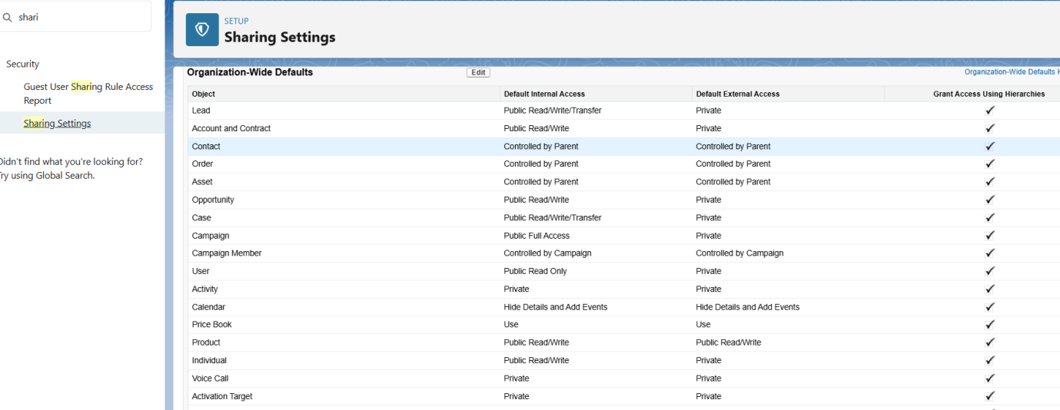

**Session Settings & Login IP Ranges**

* Configured IP restrictions for admins.
* Applied login hours for sales reps.

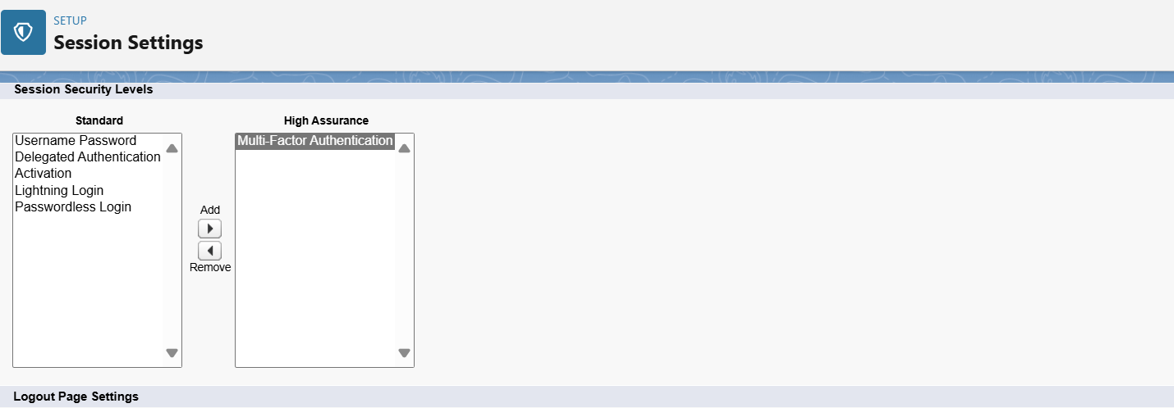

**Audit Trail**

* Monitored setup changes and user activity logs.

**4. Deliverables**

* Reports and dashboards for strategic insights.
* Strong field-level and object-level security.
* Audit trail for compliance.

**5. Conclusion**

Phase 9 delivered **data-driven insights** while ensuring **enterprise-grade security controls** for V-Electronics.